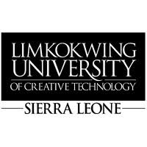
21 October, 2026.
The Director General
Sierra Leone Road Safety Authority (SLRSA)
Freetown, Sierra Leone
Dear Sir/Madam,
RE: REQUEST FOR RESEARCH SUPPORT – ROAD-SAFETY REPORTING AND COORDINATION
Limkokwing University of Creative Technology, Sierra Leone, is pleased to introduce three final-year students undertaking their dissertation titled “SaloneFix: A Human-First Public-Service Reporting and Accountability Platform for Freetown, Sierra Leone.”
The University kindly requests SLRSA’s support in helping the students understand current road-safety reporting, inspection, information-management and coordination processes, including how road-safety concerns are distinguished from road-maintenance issues and how relevant reports are assigned and followed up.
The students may require a brief interview, observation of non-confidential reporting or coordination procedures, and access to relevant non-confidential information, subject to SLRSA’s approval. All information collected will be used strictly for academic purposes and treated confidentially.
The University would greatly appreciate your cooperation and assistance in facilitating this research.
Yours faithfully,
Sheku Deen Kamara
Year Leader
Limkokwing University of Creative Technology, Sierra Leone
Email: sheku.dkamara@limkokwing.edu.sl
Student Details:
Ina M.E. Conteh | Sahid A.G. Conteh | Mark Lamin Ellie
Bachelor (Hons) in Software Engineering and Multimedia – Level 4

